Shabbos Stories for
Parshas tazria 5782
Volume 13A, Issue 32 - 1 Nisan 5782/April 2, 2022
Printed L’illuy nishmas Nechama bas R’ Noach, a”h

For a free subscription, please forward your request to keren18@juno.com
Past stories can be found on the website ShabbosStories.com

The Day the Rebbe Sent
His Russian Guests to
Go and See Reb Moshe
By Daniel Keren
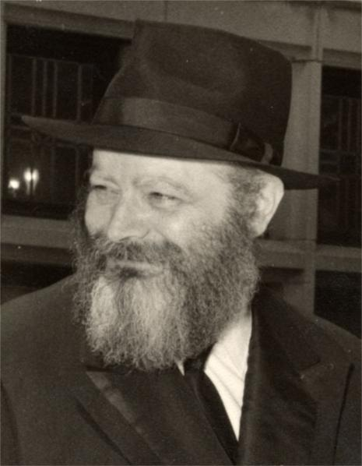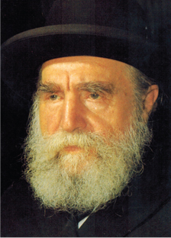
The Lubavitcher Rebbe and Rav Moshe Feinstein, of blessed memories
Since the petirah of Rabbi Menachem Mendel Schneerson, the Lubavitcher Rebbe of blessed memory in 1994, the Jewish Educational Media (JEM) Foundation, a Chabad non-profit organization has conducted video interviews with thousands of individuals who had significant moments with the Lubavitcher Rebbe.
Every week, JEM publishes a two-page Here’s my Story that features excerpts of some of those interviews. The recent interview published for Parshat Pekudei with Rabbi Yoseph Yitzchak Zaltzman was titled “The Child Who Had to Disappear.”
Rabbi Zaltzman has been a Chabad emissary in Toronto since 1980 where he founded the Jewish Russian Community Centre of Ontario. In his interview with JEM, Rabbi Zaltzman recalled that he was born in Dushanbe, the Tajikistan capital in 1956 when the Bolshevik Communist rule brutally oppressed Jewish religious life in the former Soviet Union. He was one of six children, which by that time was such an unusual situation as to result in the Soviet government bestowing a ”Heroic Mother” medal to his mother. One of the benefits of that honor was that the family received an extra 11 rubles each month in order to buy more milk.

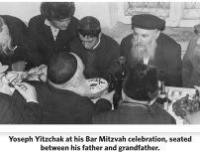

How does a Jewish boy manage to maintain his Judaism in a country that persecutes those who try to teach Yiddishkeit to children? When Yoseph Yitzchak came of age, his parents told him that in order for him to continue in yeshivah, he “would have to disappear.” How does a school child “disappear?” His parents explained that starting from September until mid-June when other children are in the government schools, Yoseph Yitzchak was not allowed to go outside or even near a window. Absolutely nobody should know that such a child exists.
Living a frum (religious) life under constant fear of being caught came to an end in 1971 when his father’s application to emigrate from Russia to Israel was approved. Shortly after arriving in Israel and enrolling in the Chabad yeshivah, Yoseph Yitzchak found out that his father was traveling to spend the High Holidays with the Lubavitcher Rebbe and was able to get his parents to buy an extra ticket for him to fly to New York for the opportunity to meet the Rebbe.
During that visit while Yoseph Yitzchak was standing the 770, the main Chabad Shul in Eastern Parkway in the Crown Heights section of Brooklyn an announcement was made: the Lubavitcher Rebbe wanted to see all of his Chassidim who had just came out of Russia.
With others, Yoseph Yitzchak was admitted into the Rebbe’s room by Rabbi Chaim Mordechai Aizik Hodakav, the Rebbe’s secretary. After everyone who had just left Russia was in the Rebbe’s room, the Rebbe closed the book he had been reading and after looking at all those in the room declared:

Commanded to Go and See Rav Moshe Feinstein
“I want you to go to and see Reb Moshe Feinstein.”
Yoseph Yitzchak explains that Reb Moshe was the greatest Halachic authority of his time, but coming from Russia, he had never even heard of him. The Lubavitcher Rebbe instructed Yoseph Yitzchak and his fellow Russian emigres that when they met Rav Moshe Feinstein:
“Go, and tell him the way it was. And don’t be humble about it. I want him to know how the chasidim survived in Russia.”
Leaving the Rebbe’s office, they went straight into a few cars that were already waiting outside. One of them was even the Rebbe’s car, which is where Yosef Yitzchak sat in the back seat. As he recalled:
“We arrived at Reb Moshe’s home and sat with him on a few coaches. First, he spoke with the adults and then moved on to us younger boys: Myself, Yosef Yitzchok Mishulovin and Shmuel Notik.
“What have you been studying? He asked us.
“We had been learning the chapter Ha’omer, from Tractate Kiddushin of the Talmud, and he began by asking us a few questions about the Mishnah there. When I answered, I saw that he took out a handkerchief and began wiping his eyes. My first thought was that I had offended him somehow.
“Somebody, told him that Reb Yankel Notik, Shmuel’s father knew the entire Talmud.
“Is it true?, he queried, turning to him.
“Not all of Shas,” he replied, “Maybe half.”

Reb Moshe Smiled
“It’s only half,” someone interjected, “but whatever you’ll ask him will turn out to be in the half that he knows.” Reb Moshe smiled.
“He then posed a question to the group. “How did you do it?”
“Reb Moshe was himself from Russia, and he knew what it meant to be religious there.
“Fifty years after he left, he was seeing people come out of Russia as if Communism didn’t even exist. We were fully religious, speaking fluently about the Talmud, Rashi and Tosafot in Yiddish. He was overwhelmed.
“Reb Yankel Notik responded “How did we do it? Did we have a choice?” In other words, for us, being a Jew is not a choice; there are no alternatives.”

Reprinted from this week’s edition of The Jewish Connection.

An Effort to Succeed

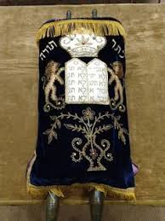

Rabbi Joey Haber told a story about a man whose effort proved to be invaluable. The man was asked to fly a Sefer Torah from one country to another. He got to the security line and was immediately confronted. “Sir, what is this?” the TSA agent asked. “It’s a very holy religious object.”
The agent said, “Well it’s going to have to go underneath the plane with the luggage. You can’t carry that with you.” The man replied, “Absolutely not, please just let me through. This needs to stay with me at all times.” She saw it was important to him and answered, “Okay. You can try to go to the gate with it, but there’s no way they’ll let it on the plane.” And she cleared him through security.
When he approached the gate, the man at the gate stopped him. “Sir, what is that?” “This is my Torah,” he answered. The man at the gate shook his head. “I was cleared through security, and it has to fly with me. I can’t separate from it; it’s really important.”
The man at the gate called his supervisor and after some deliberating, he said to passenger, “If you want you can try to get on the plane but they’re going to stop you at the door again. I’m telling you there is no way they’re going to let you on that plane with that.” The man happily went through and waited for his next hurdle.
As he stepped on the plane with the Sefer Torah, the head flight attendant said, “Uh sir, no you can’t bring that on this plane. You have to gate check that. Otherwise, we won’t be able to take off.” The man stressed how important this holy article was and begged them to let him keep it with him for the flight. The flight attendant went to get the pilot to ask special permission, and the man braced himself waiting for the final answer.

The Pilot Comes Out of the Cockpit
The pilot came out and said, “What’s going on here?”
The man started rambling, “This is my Torah and it’s extremely important, and I need it to fly with me so I could make sure nothing happens to it.”
The pilot said, “Well you can’t keep it here, but no problem, you can keep it up in the cockpit with me, because that’s where I keep my tefillin.”
When we want to achieve something, we can’t just sit back. We have to do everything in our power to succeed, just as B’nei Yisrael put their blood, sweat, and tears into trying to build the Mishkan. May we see many berachot and successes from our efforts, and may we always be the backbone of Torah, whether we are the learners or supporters of those who study. Amen!

Reprinted from the Parshat Pekudei 5782 email of Rabbi Amram Sananes as written by Jack E. Rahmey.

Transferring the Power of Blessing

Before the Nazi invasion of Hungary in 1944, the Belzer Rebbe, R’ Aharon Rokeach zt”l, who was at the top of the Gestapo’s wanted list, was miraculously smuggled from Poland into Budapest. His wife, children, grandchildren, and in-laws had been brutally set aflame by the Nazis - literally burned to death - and the Rebbe himself was marked for deportation to the death camps.
In a harrowing escape, a Hungarian counter-intelligence agent who was friendly to Jews whisked the Rebbe, his younger brother, and his gabbai, into Hungary. Their rabbinic beards and payos shaven, they were disguised as Russian generals who had been captured at the front and were being taken to Budapest for interrogation.
Throughout their 250-mile drive across German-occupied Poland to Hungary, they had one close call after another, but miraculously evaded detection. At one check point they were detained and almost exposed, but then, as if from nowhere, three high-ranking Hungarian officials appeared and ordered that their vehicle be let through.

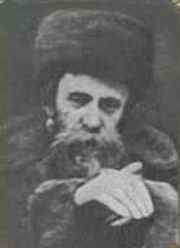
The Belzer Rebbe, zt”l

When the news of the Rebbe’s arrival in Budapest reached the Jewish community, there was great excitement. R’ Avraham Jungreis zt”l, the chief rabbi of Szeged and a prominent leader of Hungarian Jewry, like many others, sought a meeting with him.
When it became known in the hamlet of Szeged, that R’ Avraham was actually traveling to Budapest to see the holy Rebbe, countless Jews came to his home, not only from the community, but from a number of the outer provinces as well.
They all brought with them kvitlach - petitions - asking the Rebbe for his beracha. So it was that R’ Avraham arrived at the Belzer Rebbe’s dwelling with a suitcase that was literally filled to the brim with these kvitlach.

Entered the Belzer
Rebbe’s Inner Room
He was welcomed into the residence and with great respect and trepidation, he entered the Belzer Rebbe’s inner room. The Rebbe greeted him warmly and spoke to him for a minute. But when the Rebbe beheld the suitcase and its contents, he said, “Szegediner Rav, gloibt mir, ich hub nisht kein koyach - Believe me, I simply have no strength, but I give over to you all the berachos, blessings. Whomever you bless, will be blessed.” R’ Avraham’s daughter, Rebbetzin Esther Jungreis a”h, commented that looking back upon those years, she often thought that the Belzer Rebbe, with his piercing gaze, must have seen the great love that her father harbored in his heart for every person, and it was that which impelled him to transmit the power of blessing to him.
Her father accepted this trust with awe and trepidation. Indeed, he was imbued with a special ability to bless people, and his blessings were sought after for their effectiveness. He never tired of blessing people, and continued to do so till his dying day.
R’ Avraham’s grandsons, who spent Rosh Hashanah and Yom Kippur at his side for many years, would relate that the very short walk from the Beis Medrash to his house would take well over an hour, for their grandfather would stop to greet everyone he met on the way and impart a blessing to them, regardless of who they were or what their level of religious commitment. Through her outreach work in the Hineni Kiruv organization, Rebbetzin Jungreis had the zechus of bringing multitudes of people from every walk of life back to the fold. She would take them all to her father, who would bless them - and through those blessings, he became not only their Rebbe, but their zeida, as well. Although he never mastered the English language, and these people did not speak Yiddish, with his blessings, R’ Avraham transcended all language barriers.
A young man, a student at Columbia Law School who was ensnared in a cult, was literally dragged to a Hineni Torah seminar by his desperate mother. She forced him to come and he walked in looking obviously out of place.
R’ Avraham was present at the seminar and spotted him immediately. He strode over to the boy and with great emotion, embraced him, wept over him, and lovingly said, “Du bist a tayere Yiddishe kind - You are a precious Jewish child.”
As he warmly hugged him and his tears washed over the boy’s cheeks, he invoked the blessings of our patriarchs - and those blessings worked like magic! In an instant, this lost, assimilated student took a leap that spanned the centuries and returned to his faith.

Reprinted from the Parshas Pekudei 5782 email of Torah Tavlin.

The Real Reason for Long Life
By Rabbi Mordechai Levin

The great Mashgiach, Rav Chatzkel Levenstein, ZT"L, was once in a monit (taxi) returning from a funeral in B’nei Brak. One of his students who were accompanying him commented that the deceased had lived a very long life. The taxi driver said that in his small village everyone lived until a ripe old age. He stated that it was due to the very healthy, organic, locally grown food that everyone in his village ate.

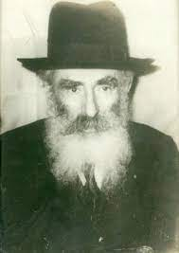
Rav Chatzkel answered the driver that he was incorrect! The reason why the people in his village lived long lives was that there weren’t many people in that village. Therefore, there wasn’t a lot of Lashon Hora (evil speech) spoken there. That must be why they had the bracha (blessing) of lengthy lives, as opposed to attributing it to simply eating healthy foods. To Rav Chatzkel it was clear as day that true bracha can only come from following Hashem’s wishes.

Reprinted from the Parshas Pekudei 5782 email of R’ Mendel Berlin’s Torah Sweets Weekly.

Story # 1265
Raspberry Preserves
From the desk of Yerachmiel Tilles
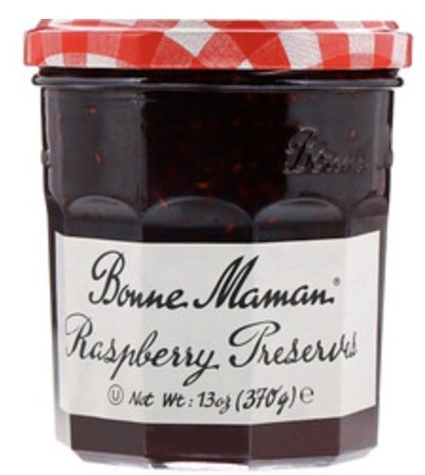
Professor Michael Perino and the special jar of Raspberry Preserves

At a supermarket in New Jersey one Sunday [in 2021], Professor Michael Perino found a small, elderly woman standing in front of a high shelf holding ‘Bonne Maman” preserves. She was having trouble finding the flavor she wanted because the jars were set back on the shelf.
She couldn't read the labels. She could barely reach them. He offered to help.
After he handed her the raspberry preserves, she thanked him, paused, and then asked, "Do you know why I buy this brand?"
He laughed and replied, "Because it tastes good?"
"That’s true, true, it tastes good. But that’s not the reason."
She paused again. "I am a Holocaust survivor."
This was not the sort of conversation one would expect on a Sunday grocery run!
She continued. "During the war, the [Chapoulart] family that owns the company hid my family. So now I always buy it. And whenever I go to the store, my grandkids remind me, ‘Bubbe, don't forget the jelly.’"
That was the best reason I ever heard to buy any company's product, Perino thought to himself. Then he smiled and she smiled behind their masks, and they went their separate ways.
The professor researched the story and indeed, the town that Andros Company, the makers of Bonne Maman, comes from, hid and saved Jewish families in WW2. It was called Biars sur Cere [located in southwestern France], which then had about 800 villagers.
This is an excerpt from an article he found: "You have to understand what it was like then. There were posters on the walls, from the Nazis and from the collaborators, and they said if you were found to help a Jew, a freemason, a communist, a socialist, or a pervert, you will be shot on sight. Despite the great danger in which helping put the villagers in, still they kept the children safe."
She was right it’s a good reason to buy Bonne Maman products. And, concluded Professor Perino, a poignant reminder that when we look out for each other it can change lives, and that there are good and selfless people in the world.
~~~~~~~~~~~~~
Source: Adapted and supplemented by Yerachmiel Tilles from the report by Rabbi Yisrael Bernath, which is based on .
Connection: Revealed reason: This week we append to the weekly Torah reading the passage (Deut. 25:17-19) about Amalek called Zachor and almost for sure the Jew-hating Nazis (as in this story) were true descendants of Amalek, the grandson of Esau.
FYI: These three verses contain three separate commandments. One of them you fulfill simply by going to synagogue this Saturday and hearing them read publicly from the second Torah scroll, after the regular weekly reading is completed.
The personal reason: I [YT] just received a jar of Bonne Maman bitter orange marmalade from Mrs. Reba-Minna Domnitz, the person who called my attention to the above story.
Professor Michael Perino is the Dean George W. Matheson Professor of Law and Associate Academic Dean at the St. John’s University School of Law. He formerly taught at Columbia Law School, Cornell Law School and Standford Law School.

Reprinted from the Parshat Vayikra 5782 email of KabbalaOnline.org, a project of Ascent of Safed.

The Brothers Fight for Their Father’s Special Sefer Torah

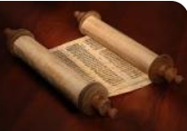
Rav Moshe Meir Weiss

Rav Moshe Meir Weiss once related a fascinating story that happened in the times of Rav Sherira Gaon, zt”l. There was a very wealthy Jew who had the special privilege of possessing a Sefer Torah that was written by the great Ezra HaSofer. This wealthy man passed away leaving two sons, but he didn’t give specific instructions regarding who should inherit this unique Torah scroll.
There was a very great dispute over it, and each one was ready to give up much of their father’s wealth in order to inherit this rare Torah. Finally, the question came before the Rabonim, who decided they should cast a lottery to determine which son should receive it. They did so, and the Sefer Torah passed into one of the son’s hands.

The Plot of the Wicked Jewish Townsman
At that time, an evil and sinful Jew lived in this town, who could not believe his eyes, at what he considered foolishness and sheer stupidity, of the son who gave up such a great portion of wealth, just for a Torah! To teach him a lesson, he snuck into the Shul one night, and secretly caused a blemish in this Sefer Torah. He opened up the Torah to the Pasuk in Shemos (23:25), “VaAvaditem es Hashem Elokeichem U’Veirach es Lachmecha, You should serve Hashem your G-d and He will bless your bread (livelihood).”
With evil intent, this wicked man changed the letter ‘Ayin’ in the word Avaditem, to an ‘Aleph’, causing it to mean the blasphemous statement, ‘That you should destroy Hashem your G-d,’ R”L!
Weeks later, when they were up to this Parshah in the Torah, the people of the town discovered this mistake. It caused a great uproar, because although it is a mistake that can be corrected, it seemed to prove, beyond a shadow of a doubt, that this Sefer Torah could not have been written by Ezra HaSofer, for there was no way that this Tzadik could have made such a terrible mistake.

The Son Became Extremely Ill
This caused the son, who gave up much of his inheritance in order to have this Torah, to become physically ill. One night, his father visited him in a dream and told him what had really happened, that a wicked Jew had come in the middle of the night and damaged the Torah. He told his son, as proof to what he was saying, he should go to the Shul and look under a certain table in the Shul, and there, he would find the scraped off ‘Ayin’ from the Torah.
He then told him not to correct the Sefer Torah, as Ezra himself would come and correct it. And so it transpired. They found the missing letter in the Shul, and when they went to check the Torah, it had been corrected!

Why was the Holy Sefer Torah of Ezra Damaged?
Rav Moshe Meir Weiss comments, that while this story is quite remarkable, why did Hashem allow Ezra’s holy Sefer Torah to become impaired? We know that Hashem gives special Divine protection to items of great holiness. Perhaps, the answer lies in the behavior of the brothers upon their father’s passing. They engaged in a fight, each one wanting to possess this special treasure. Surely, they each acted with religious zeal, thinking that in the process he was serving Hashem, desiring to sacrifice great wealth to possess the cherished Torah. But what transpired?
The ‘Ayin’ of, “Avaditem es Hashem Elokeichem, You should serve Hashem your G-d,” in this very Torah, was changed to an ‘Aleph’, in order to show that in the very act which they thought was serving Hashem, in reality was causing Hashem to distance Himself from them, for there is no greater way to chase Hashem from a place than to engage in Machlokes.

The Great Evil of Machlokes (Disputes)
The brothers caused that the word for serving Hashem, Avaditem, should be maliciously changed, and caused Hashem, so to speak, to ‘disappear’, to teach them and the townspeople this vital lesson, that even under the pretext of serving Hashem, one should not fall to the great evil of Machlokes, even with the excuse that you are doing it ‘L’Sheim Shamayim!’

Reprinted from the Parshas Pekudei 5782 email of Rabbi Yehuda Winzelberg’s Torah U’Tefilah
The Impossible,
Possible Climb
By Rabbi Dovid Goldwasser

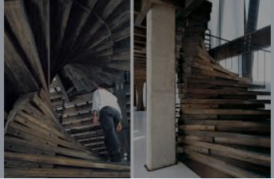

A beloved king who led his subject with wisdom and distinction was getting old. He no longer had the vigor and stamina to govern the people, and he decided to seek a faithful and capable individual who could serve as his viceroy.
The king traveled far and wide, without success. When he returned, he hired contractors to build a many-storied palace in the center of town, with the very top floor of the house to be the office of the viceroy. No expense was spared in the construction. It was a beautiful edifice with only one peculiarity.
The staircase to the top was designed with oddly shaped steps, each one irregularly spaced from the other, with some steps high, some deep, and others turning sideways or sticking out at odd angles. It was like an obstacle course, and one would have to tread very carefully to make his way to the top.
Satisfied with the results, the king then sent out a proclamation that the first person who would successfully climb the staircase within half an hour would be the viceroy. There were many applicants, wise individuals and strong men, who all made the attempt. However, after starting the climb and seeing how long it was taking them, they soon gave up. Word spread that it was an impossible challenge.
An intelligent Jew who knew that the king was a capable and astute individual realized that there must be something more to this challenge than met the eye. The man studied the convoluted and circuitous construction and began to climb one step at a time. He climbed step after step. After he had ascended ten steps, he saw there were more, each one more difficult than the previous. He felt he had no more strength left, yet he continued to make his way up, because he believed in the king and knew that there must be a method to this madness he persevered, ignoring the jeering and taunts.
He had only seven minutes left to climb, and there was still a long way to go, but he pressed on. At the 27th minute he hit a wall that looked unbalanced. When he touched the wall, it suddenly moved, and beyond it was a straight path that led directly to the top. The Jew became the viceroy.
Rav Gamliel Rabinovich explains it is so with the service of Hashem. At first it seems to be an impossible task. How could Hashem request mortal man to add holiness and purity to himself to such an extent? But the King does not ask what is beyond man’s ability.
The initial steps may be difficult, but one should continue his spiritual ascent all his life without stopping. Ultimately it will be as our Sages tell us, “If a person sanctifies himself a little bit, then from Heaven he will be greatly helped to be holy.” With the sacrifice offering one ascends the rungs of holiness and merits to become a viceroy of the King.

Reprinted from the Parshat Vayikra 5782 website of The Jewish Press.

When to be or
Not to be Humble

Rav Galinsky relates the following story:
When the Belzer Rebbe, Horav Yissachar Dov, zl, was told of the invention of the phonograph, he was not impressed. Indeed, the concept of recording and reproducing sound was not new. He claimed to have been aware of this phenomenon for years.
It heralded back to the time when the vision of the first Belzer Rebbe, the Sar Shalom, zl, began to fail due to old age. His mind was in the Himelen, Heavens, when he heard the noise of his grandson playing in the courtyard. He asked his gabbai, aide, to see who was disturbing him. When he heard who it was, he called for Yissachar Dov to come in.
“What did you learn about today in cheder?” the Rebbe asked.
“I learned that Hashem spoke from the burning bush and dispatched Moshe to Egypt to redeem the Jewish People,” the child replied.
“Did you understand what you learned?” the Rebbe asked.

Why Was Hashem Upset with Moshe?
“Truthfully, I had a question that bothered me” was the response. “Moshe Rabbeinu was the most humble man to walk the face of the earth. He was not looking for kavod, glory. So, why, when he refused to accept the helm of leadership, did Hashem become upset with him?”
The Rebbe was impressed with his grandson’s question, and he immediately replied, “When Jews are in need, and one is asked to help lead them out of affliction, it is not a time for humility. You might not understand the explanation now, because you are young. When you are older and more seasoned, you will understand quite well.”
Rav Yissachar Dov related, “I walked out of the room and met my father, who asked me, ‘What did the Zaide, grandfather, say to you?’ I told my father the truth – I had forgotten. Years passed, during which the neshamah of the Sar Shalom ascended to its rightful place in Olam Habba, the World-to-Come. His son assumed the position as Rebbe.

Trembling at the Thought of
Being Asked to be a Leader
“During the time in which he was the Rebbe, the Chassidus grew. He served his flock well until Hashem called his holy neshamah back ‘home.’ The chassidim now turned to me to lead them. I trembled at the thought. How could I possibly fill the role that had so ably been filled by my late grandfather and father? How could I even begin to sit on their throne?
“I was about to demur the request of the chassidim, when suddenly my grandfather’s reply to me years earlier came to mind: ‘When one is asked to help Jews in need, it is not a time for humility.’ I accepted the leadership of Belz Chassidus. “Nu, was that any different from the phonograph? A record was made and put away for years, and the recording was played years later.”

Reprinted from the Parshas Vayikra 5782 email of Rabbi A.L. Scheinbaum’s Peninim on the Torah.

